Links to the data source

TGCA BRCA data set
portal.gdc.cancer.gov/projects/TCGA-BRCA

Link to the data dictionary
GDC Data Dictionary Viewer: This tool provides detailed definitions and descriptions of the data elements used across TCGA datasets. You can explore the data dictionary to understand the structure and meaning of each column in your dataset.
Viewer - GDC Docs
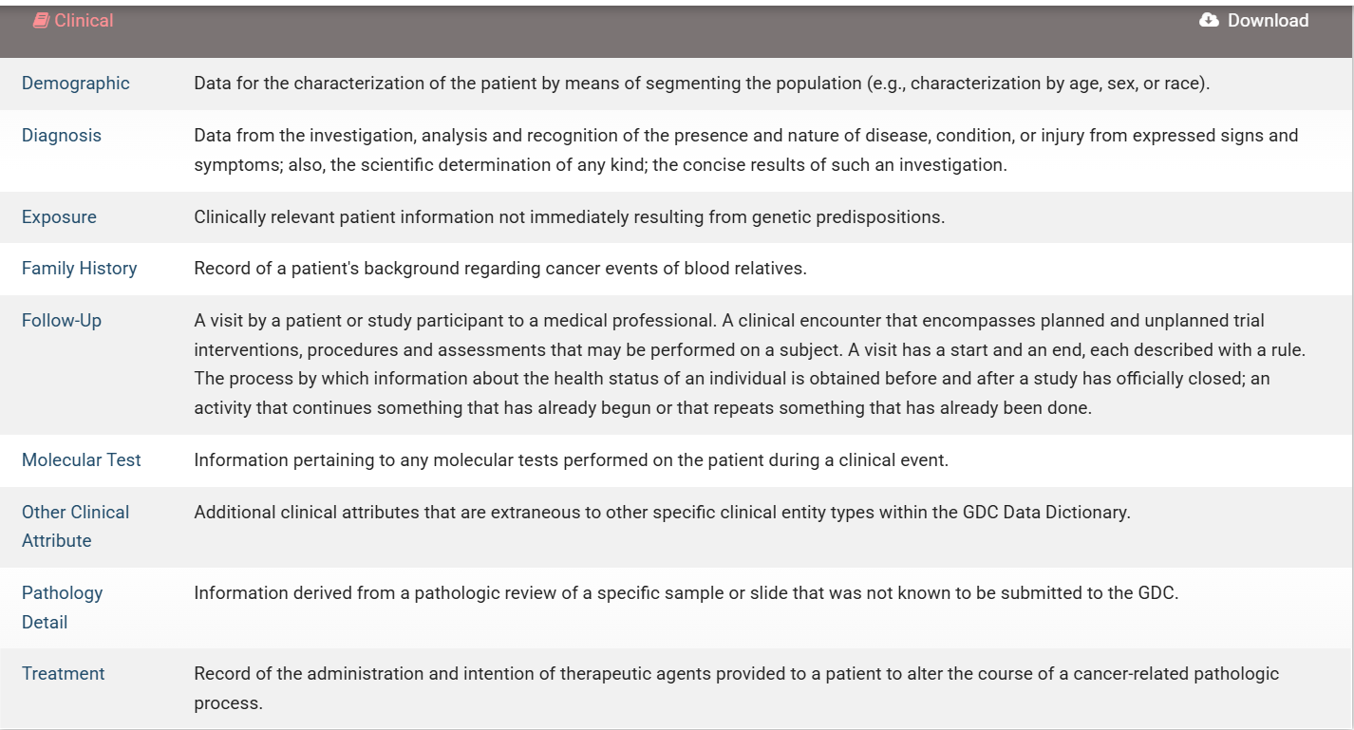

TCGA Code Tables: These tables offer explanations for various codes and abbreviations found in TCGA data, including sample types, data levels, and platform codes. This resource can help you interpret the column names in your dataset.
https://gdc.cancer.gov/resources-tcga-users/tcga-code-tables?utm_source=chatgpt.com
TCGA-BRCA Clinical Data Forms: For clinical data specifically related to the BRCA project, the Biospecimen Core Resource Clinical Data Forms provide explanations of the clinical data fields. These forms can be particularly useful if your dataset includes clinical variables.
TCGA-BRCA - The Cancer Imaging Archive (TCIA)

